ISLINGTON CENTRE – 4 July 2022

Parties
Speak about:
- different types of party
- the ingredients of a good party (what makes for a good party)?

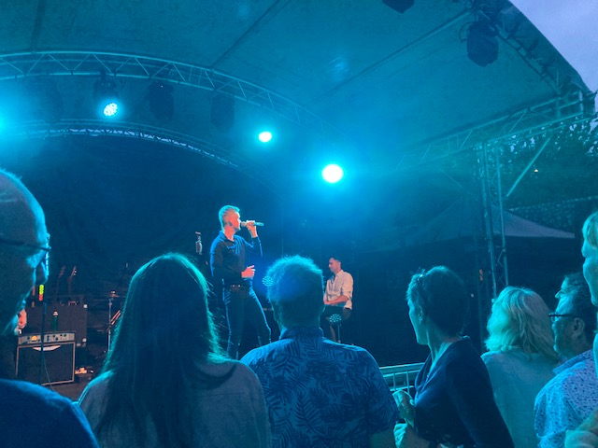

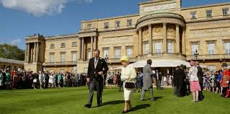



INVITATION

On 6 August Sasha will be 50!!!
Come and celebrate at
16, South Road, Norwood.
7pm – midnight on 6 August
Food, drink and dancing.
Bring some food to share.

RSVP to sasha374br@gmail.com Dress: party

Different ways of talking about the future
will, going to and present continuous

will – predictions about the future/decisions made at the moment of speaking
I think my son will be at the party.
I’ll check that the oven is turned on.
(Sometimes “going to” can also be used for predictions – I think the Lib Dems are going to win the next general election.)
going to/present continuous – decisions made before the moment of speaking (arrangements and intentions)
We’re going to meet in the restaurant at 8pm.
We’re meeting in the restaurant at 8pm.
For timetabled events, we sometimes use the present simple.
The party starts at 7pm.
Fill in using the correct future tense (sometimes there is more than one option).

I’ve been invited to Sasha’ party next Saturday. I think it [be] a warm evening and that we [be] outside in the garden. I haven’t yet decided what to wear but probably I [wear] some cotton trousers and a colourful tunic I bought at the market. As we [dance], I [wear] a pair of comfortable shoes
My brother [come] too and we [meet] before the party starts in the pub. I [cook] a chicken and I [take] a large three bean salad to the party.
Sasha has told me that the party [start] promptly at 7pm. That’s good news as on the following day, I [visit] my friend in the country so I [not/leave] the party too late.

Pronunciation


